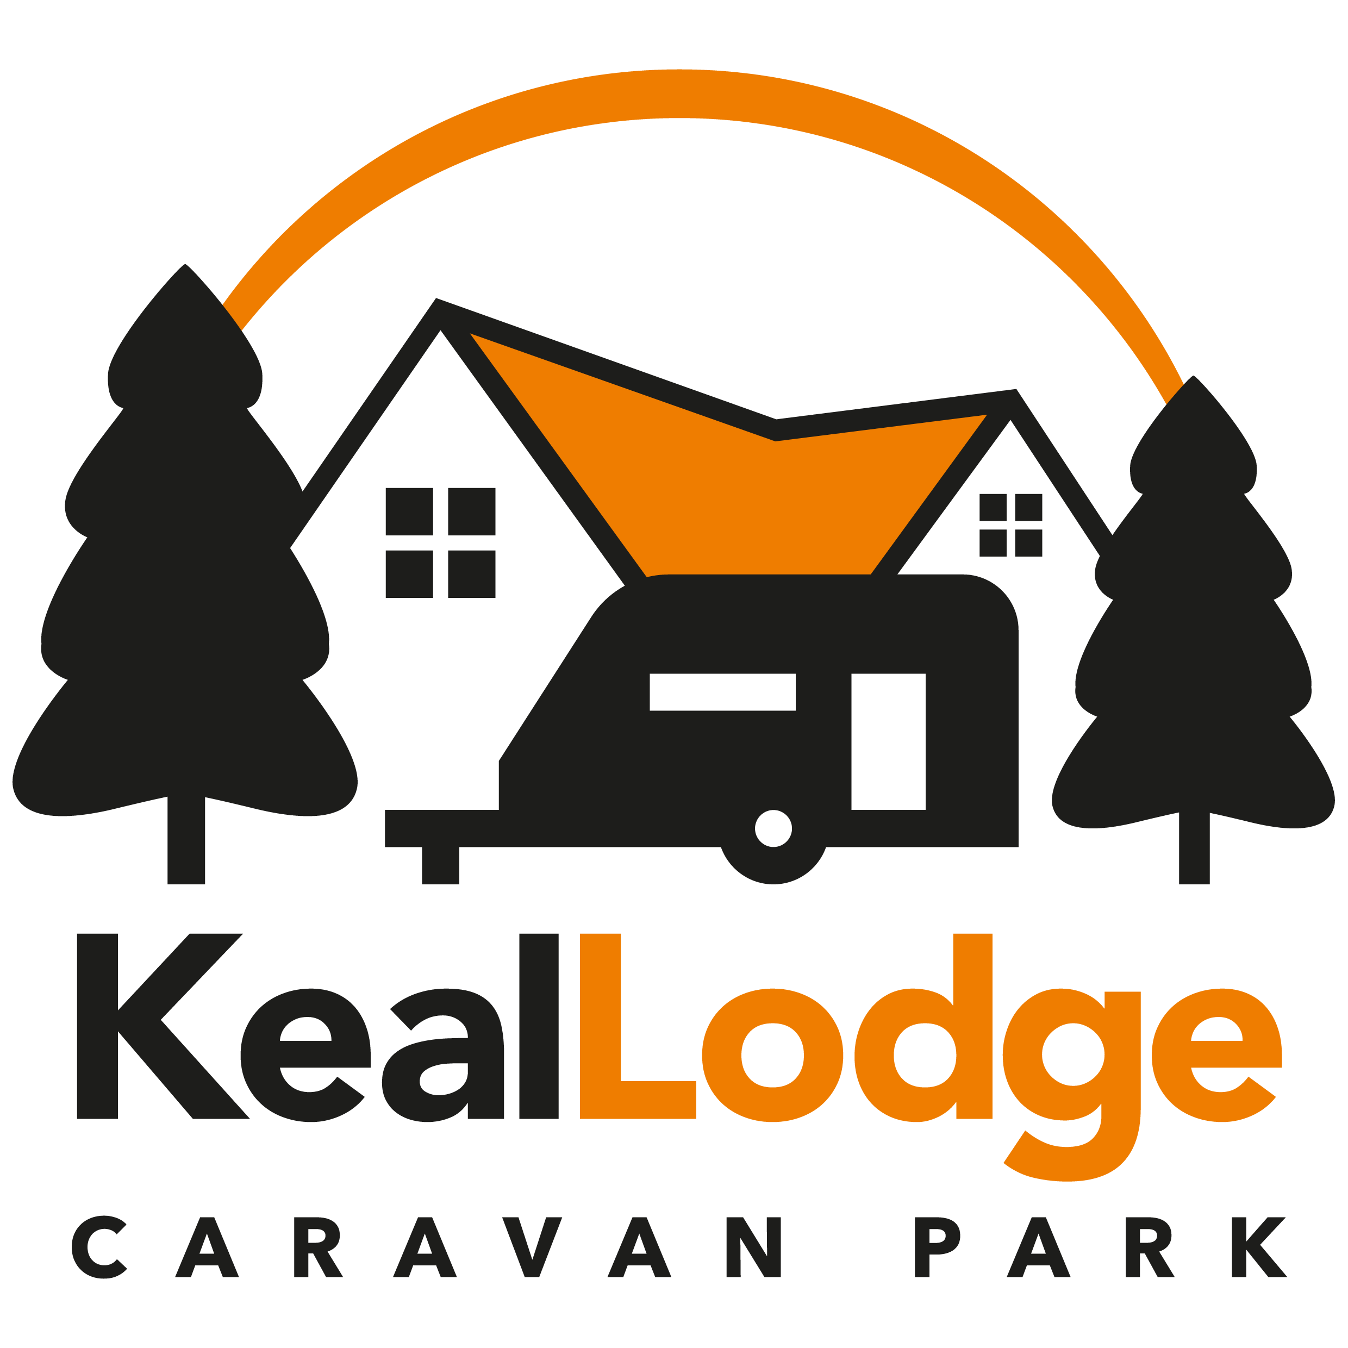

Accessibility Guide for Keal Lodge Caravan Park
enquiries@keallodge.co.uk, 01778 346946, www.keallodge.co.uk
Contact for accessibility enquiries: Helen Rogers
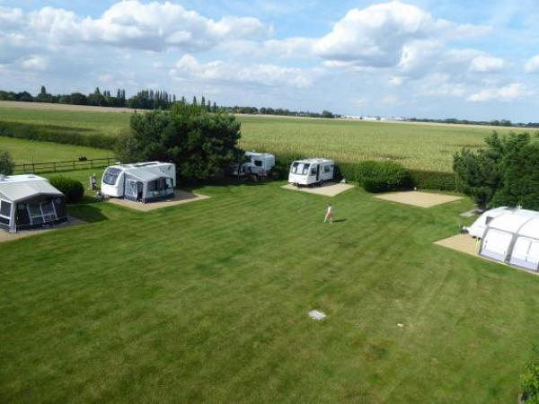

Welcome
Keal Lodge is situated in a quiet rural lane, five minutes walking distance from the village with pubs and shops. With secure access, the site is adjacent to the owners' bungalow. The site is level, lawned and landscaped with trees and shrubs. There is a well stocked information centre, night lights, chemical disposal point and MV service point for motorhomes. Free WiFi access is included.
The site has 10 all weather hard standings and 1 grass pitch (own sanitation required); each pitch has electric hook-ups, plus a mains water tap and a drain for waste water, so there is no more running out of water during your shower or over flowing waste water containers to carry!

At a Glance

Getting here
Keal Lodge
Back Lane, Deeping St James
Peterborough
PE6 8RT

Parking
- We have a car park. The parking is less than 50 metres from the main entrance. Parking is free.
- From the car park to the entrance, there is level access.

Arrival

Path to main entrance
- From the street to the main entrance, there is level access.

Main entrance
- The main entrance has level access.

Getting around inside

Site facilities
- We can help you with pitching.
- You can park next to your tent and caravan.

Customer care support

Guide last updated: 31 August 2021

